EE 586
Homework 2
Mohammad Chahrdori
Mohammad Ali Mokri
1)

2)
This is a pseudo NMOS gate. When one of the inputs is high the we have
$$I_{dp}\left(sat\right)=I_{dn}\left(linear\right)=k_{p}{\left(V_{dd}-V_{tp}\right)}^{2}=k_{n}\left[\left(V_{dd}-V_{tn}\right)V_{o}-\frac{1}{2}V_{o}^{2}\right]$$
$$V_{o}=\left(V_{dd}-V_{tn}\right)-\sqrt{{\left(V_{dd}-V_{tn}\right)}^{2}-\frac{2k_{p}}{k_{n}}{\left(V_{dd}-V_{tp}\right)}^{2} }$$
$$if V_{tp}=V_{tn}=V_{t}$$
$$V_{o}=\left(V_{dd}-V_{t}\right)\left(1-\sqrt{1-\frac{2k_{p}}{k_{n}}}\right)$$
For the given sizes we have
$$V_{o}=\left(V_{dd}-V_{t}\right)\left(1-\sqrt{1-2×\frac{1}{2}×\frac{0.6}{1.5}}\right)=\left(V_{dd}-V_{t}\right)\left(1-\sqrt{0.6}\right)=0.22×\left(V_{dd}-V_{t}\right)$$
If all input are on the driving current of the NMOS transistors are 4 times higher than the first case. So, in the derived formula we can substitute 4 times higher $k_{n}$. In this case, the output voltage would be
$$V_{o}=\left(V_{dd}-V_{t}\right)\left(1-\sqrt{1-\frac{2k_{p}}{4×k_{n}}}\right)=\left(0.0513\right)×\left(V_{dd}-V_{t}\right)$$
Now we need to check our analytically obtained results with the simulations.
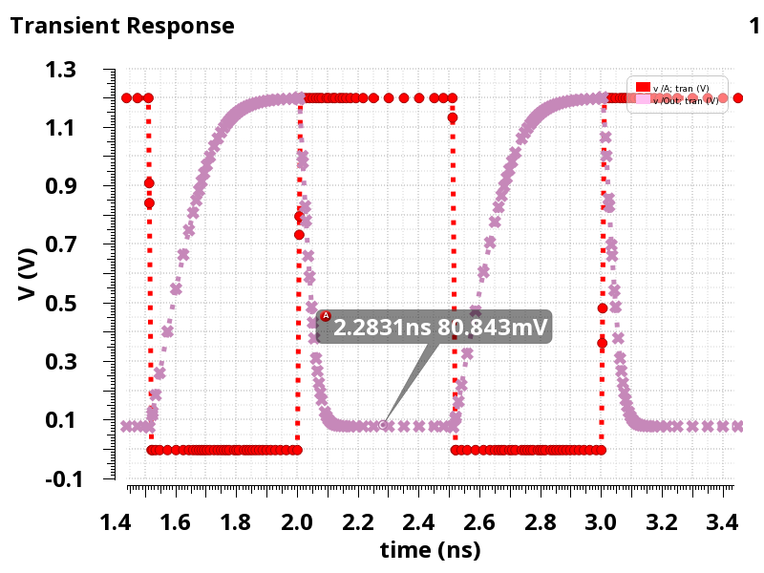
As we can see for the case in which one input is high the output voltage does not go less than 80mV.
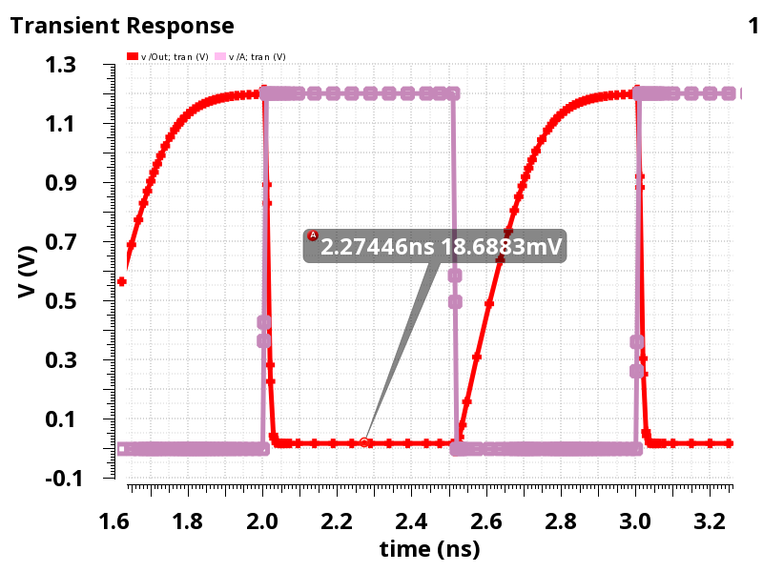
For the second case which all inputs are high the output voltage goes as low as 18mV which is much less than the first case.
In this problem the size of the transistors are chosen in which in both cases the output low voltage has enough noise margin.
3)
First we need to determine the voltage at node X. because at the steady state the current through pass transistor is zero we have.
$$I_{d}\left(pass\right)=0=k_{n}\left[{(V}_{gs}-V_{tn}\right)V_{ds}-\frac{1}{2}V_{ds}^{2}]=k_{n}\left[{(V}_{g}-V_{x}-V_{tn}\right)(V_{g}-V_{x})-\frac{1}{2}{\left(V_{g}-V_{x}\right)}^{2}]$$
$$V_{x}=V_{g}-V_{tn}=V_{dd}-V_{tn}$$
As we can see there is a voltage drop equal to threshold voltage of the pass transistor.
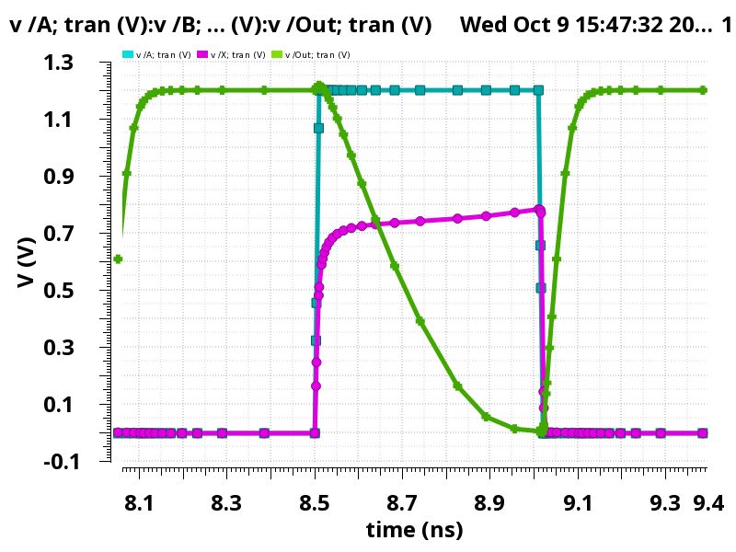
As we can see the voltage at node X is a threshold voltage less than the input voltage.
In order to restore the voltage restorer at node X we can add a restorer at node X. the circuit would be come like the figure below.
Transistor sizes are given except the restorer. Based on the graphs in the lecture notes we may choose a small size PMOS for the restorer. in order to avoid low logic problem at node X we can not pick a large PMOS for the restorer. as we can see in the graph goes to vdd for a high input and it goes to zero for a low input voltage.
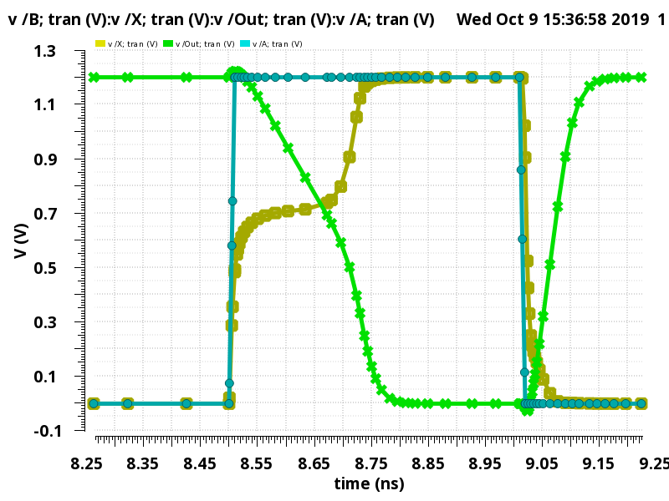
4)
In this part we use a transmission gate instead of NMOS pass transistor. We use the same size for the NMOS and 2X size for the PMOS in the transmission gate.
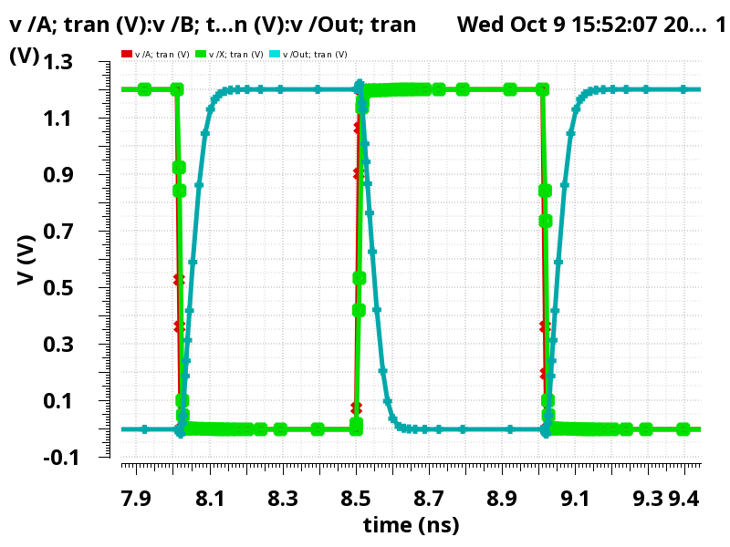
As we can see using TGate node X has a full swing without any problem.

